**PYTHON QUESTIONS**

Q1. Write Python Program to understand 5 types of built in functions to be done on Tuple.

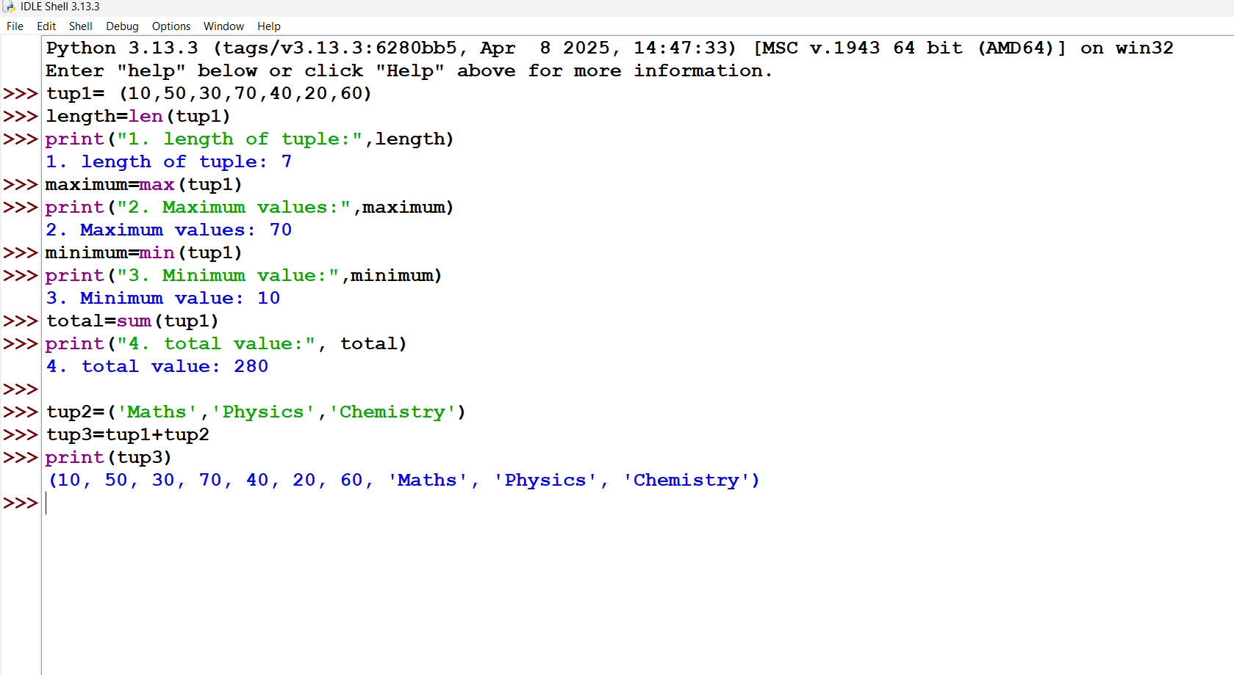

Q2. Write Python Program to understand Various types of operators in python.

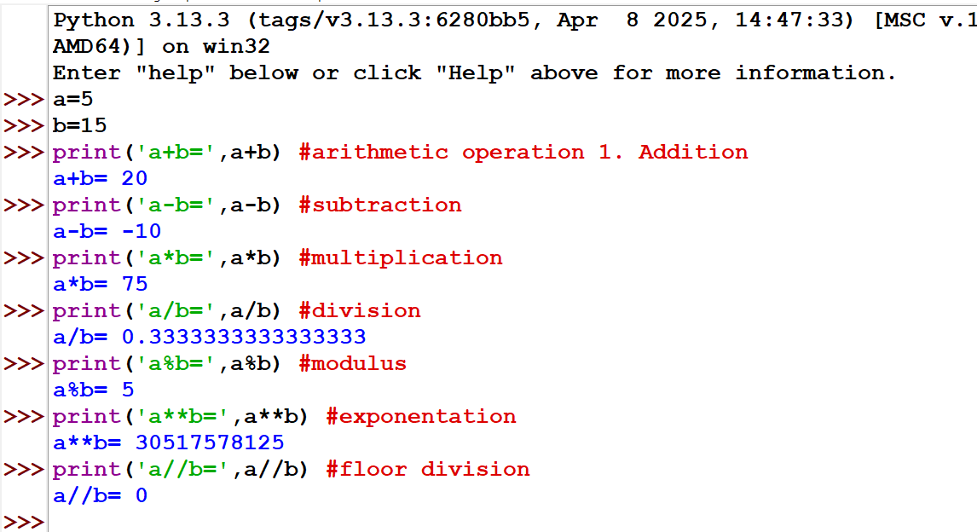

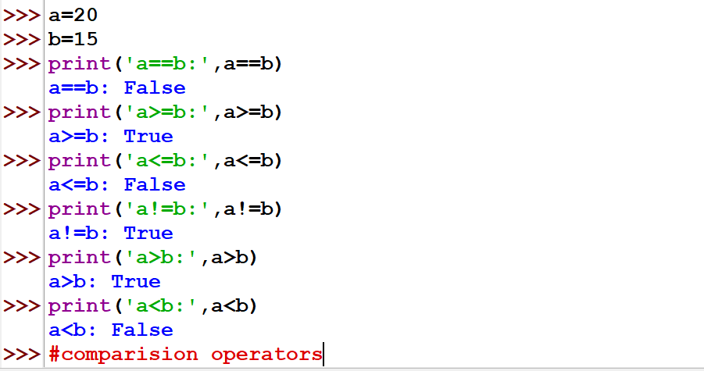

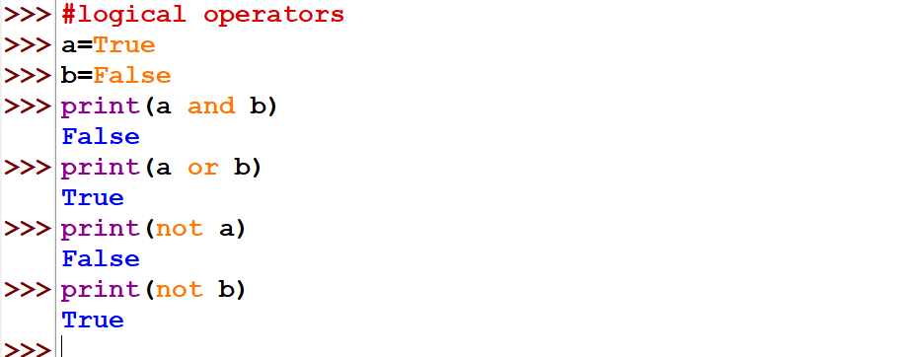

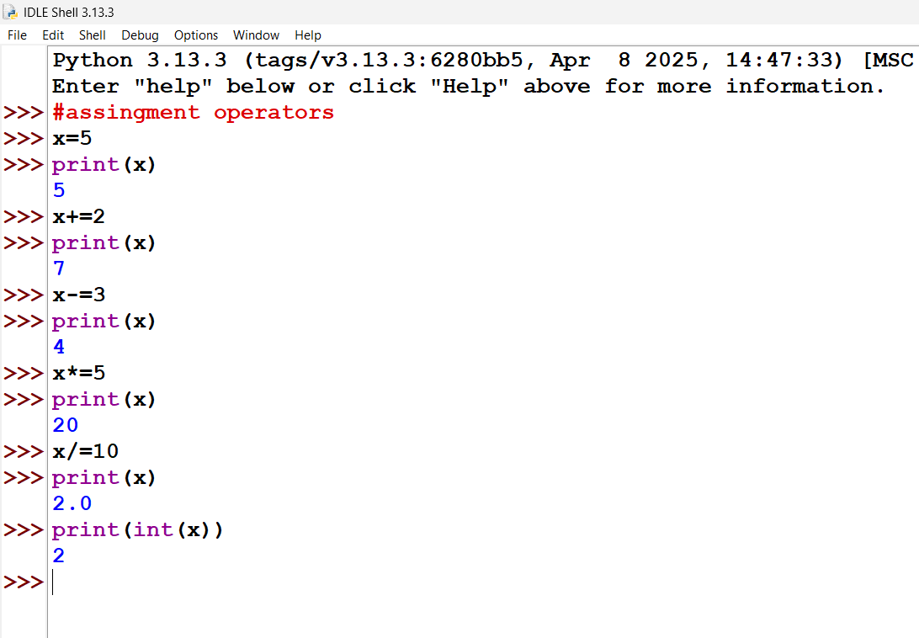

Q3. Write Python Program to understand Various types of variable assignments

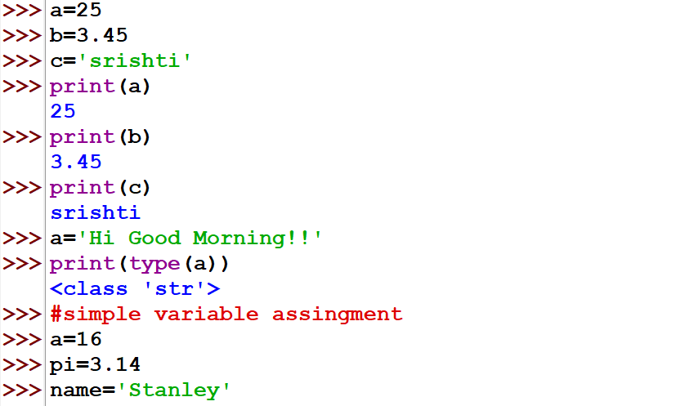

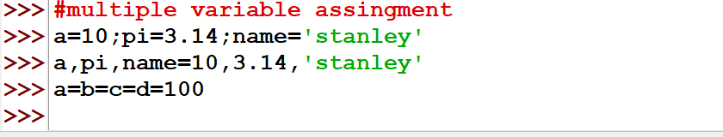

Q4. Write Python Program to understand sequencing, slicing, indexing operations to be done on string

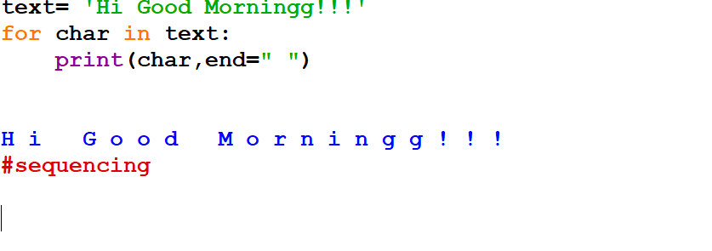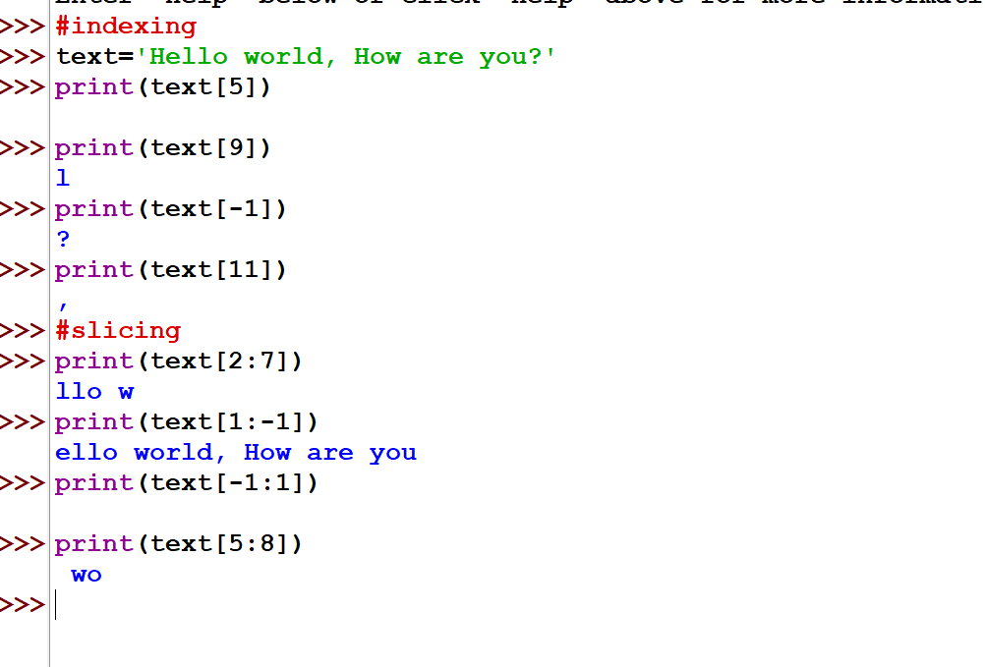

Q5. Write Python Program to understand sequencing, slicing, indexing operations to be done on tuple and dictionary.

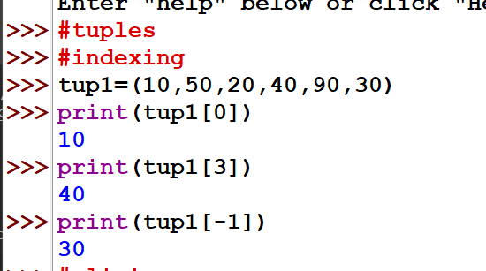

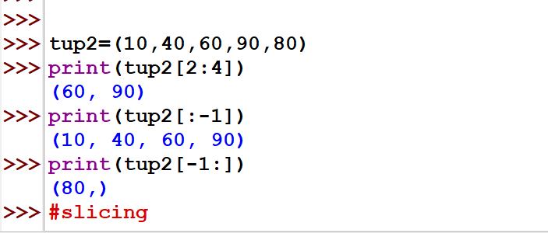

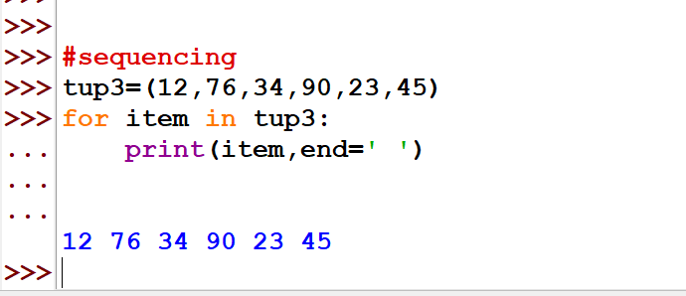

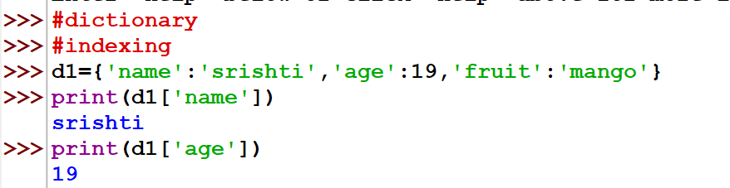

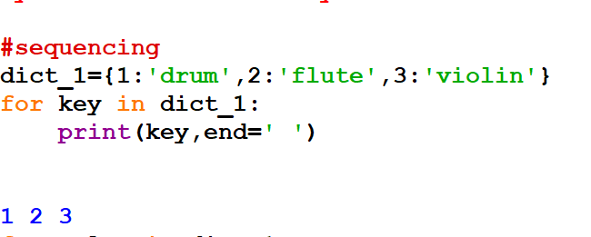

Q6. Write Python Program to understand Various types of built in functions to be done on string. 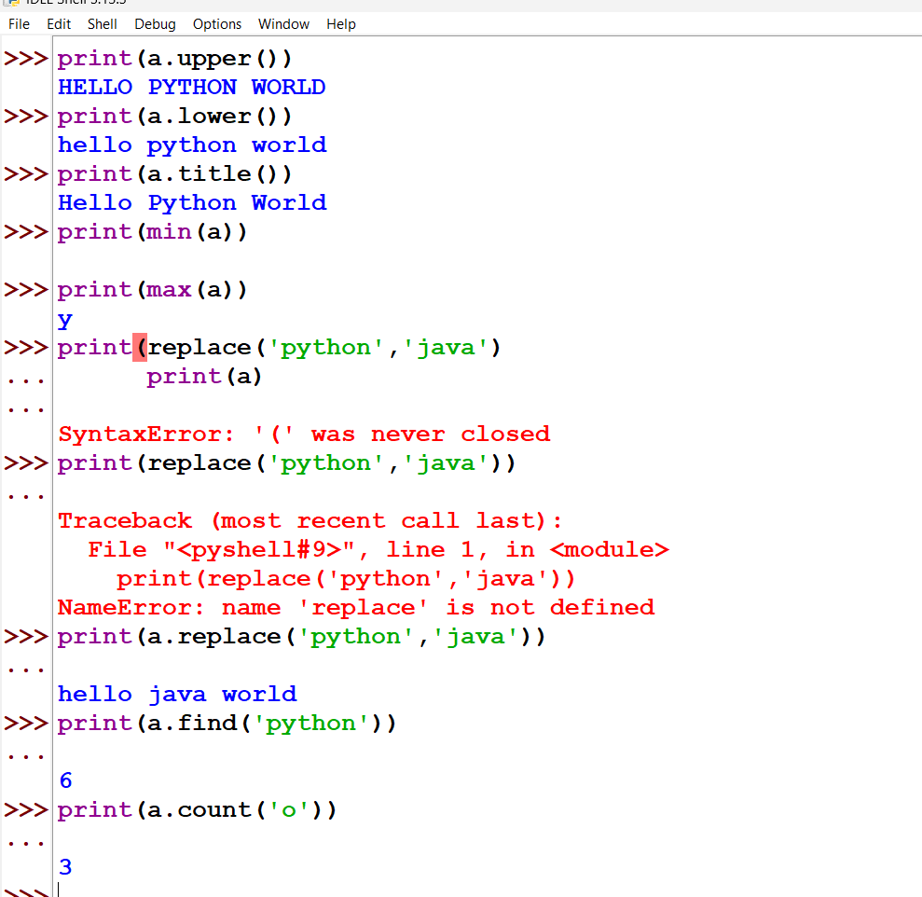

Q7. Write Python Program to understand Various types of loops (if-else, nested if else, elseif, for loop, while loop) 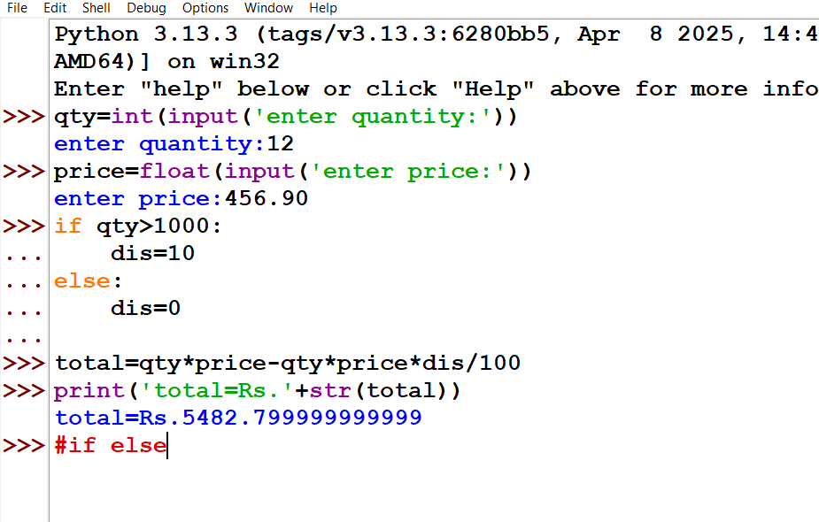

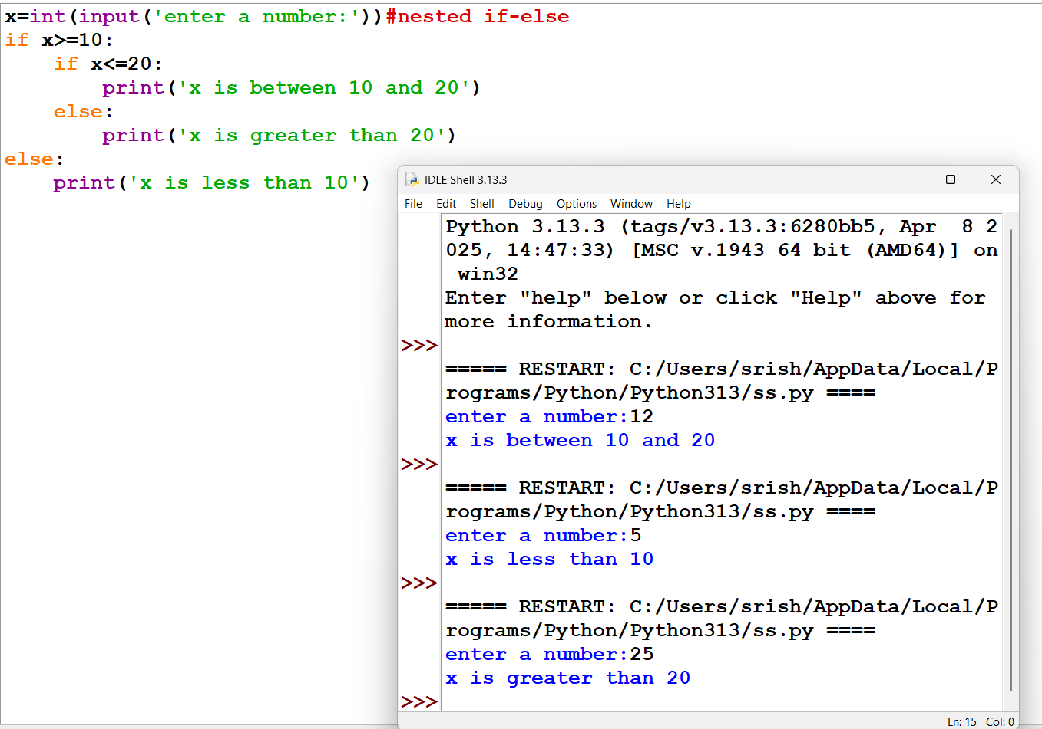

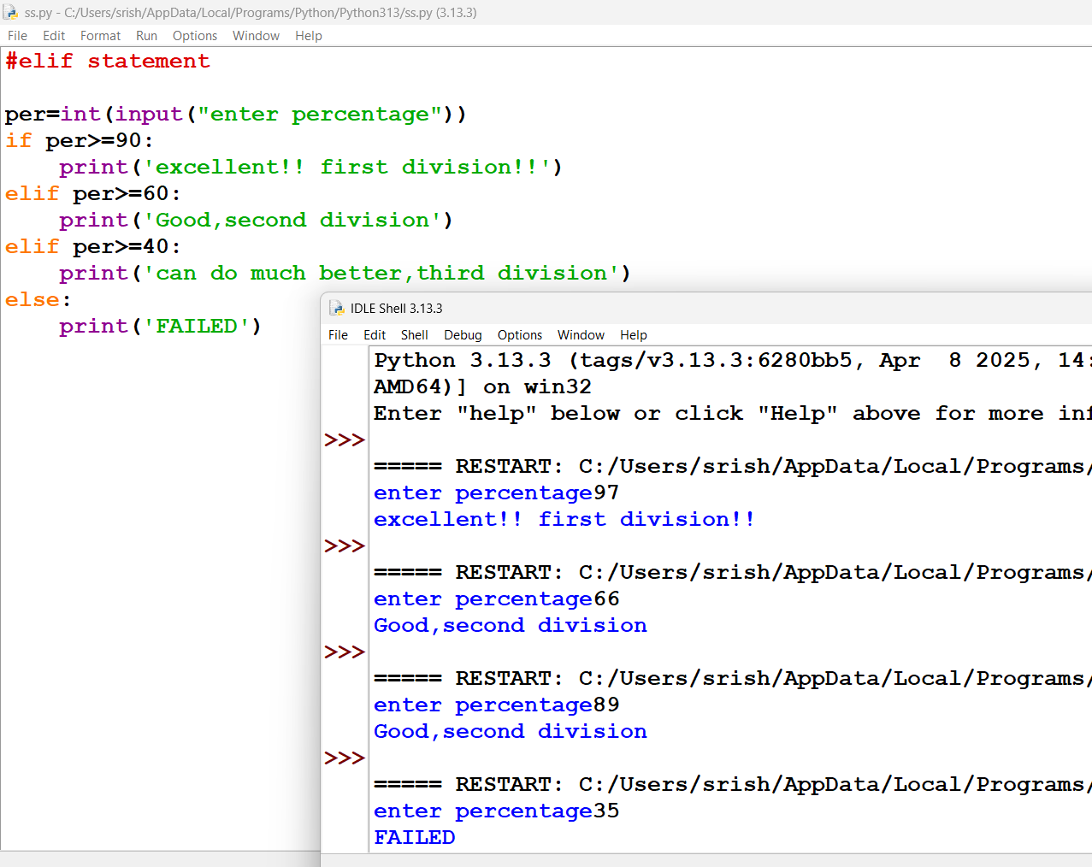

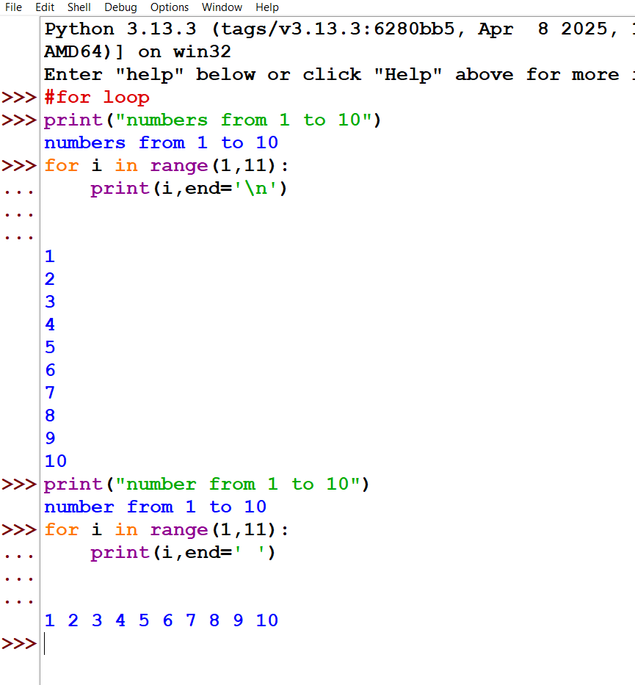

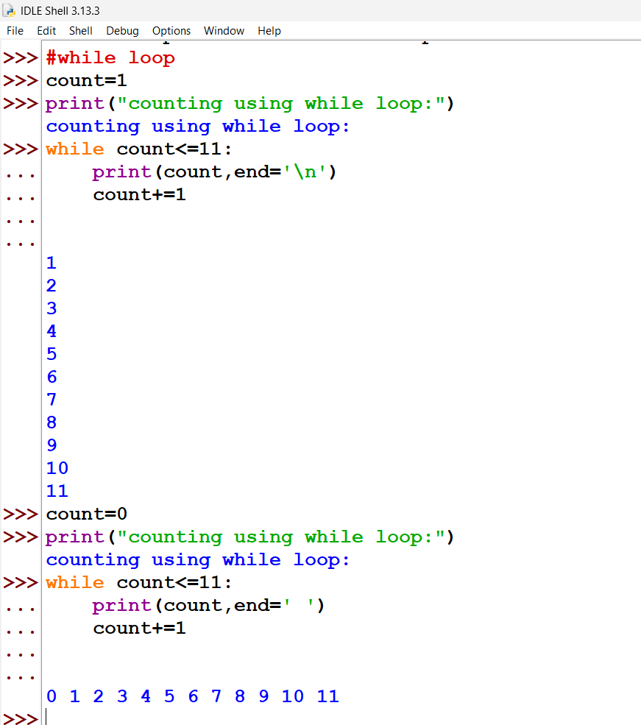

Q8. Write Python Program to understand Loops using continue & break statement.

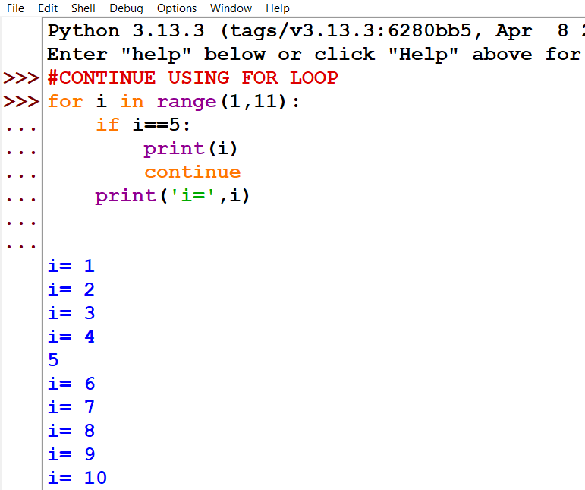

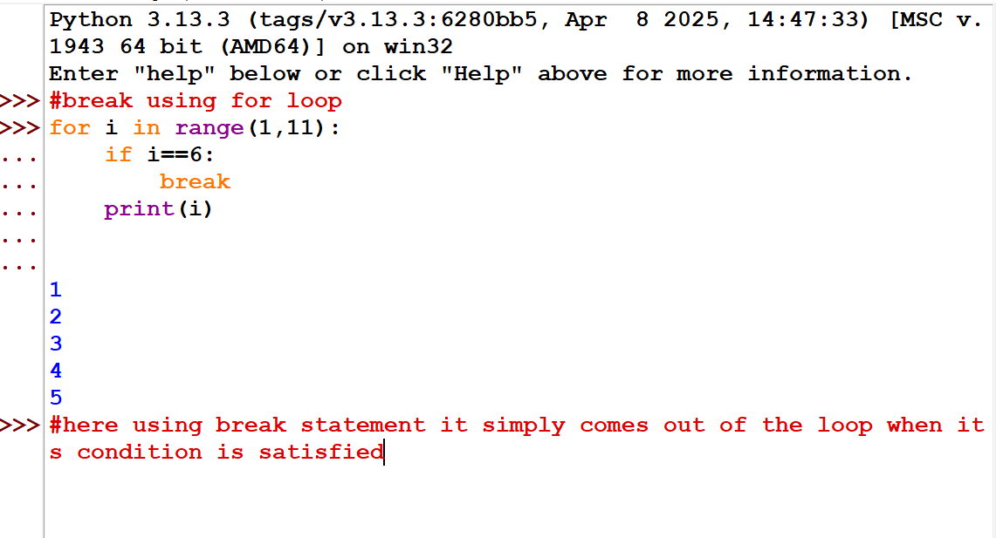

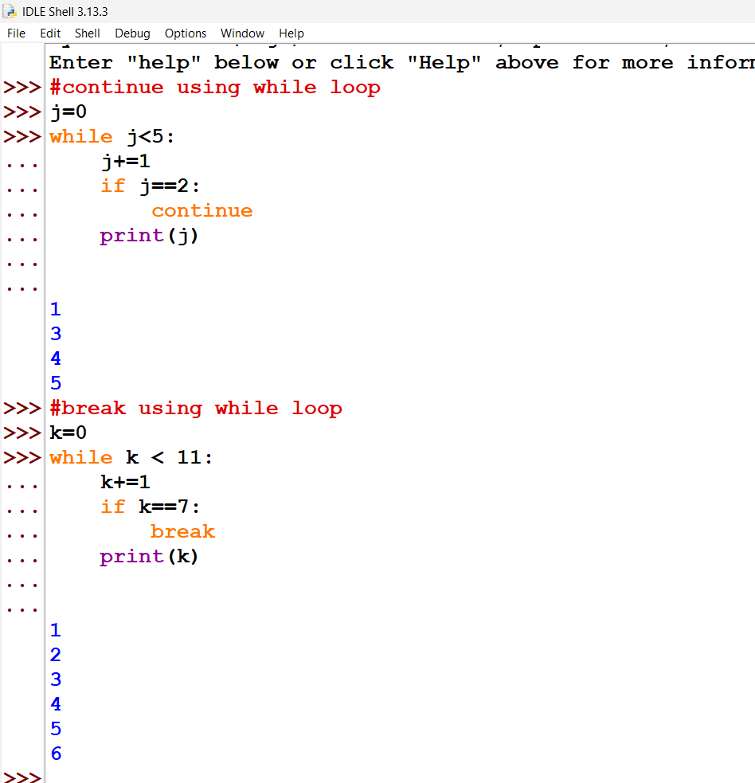

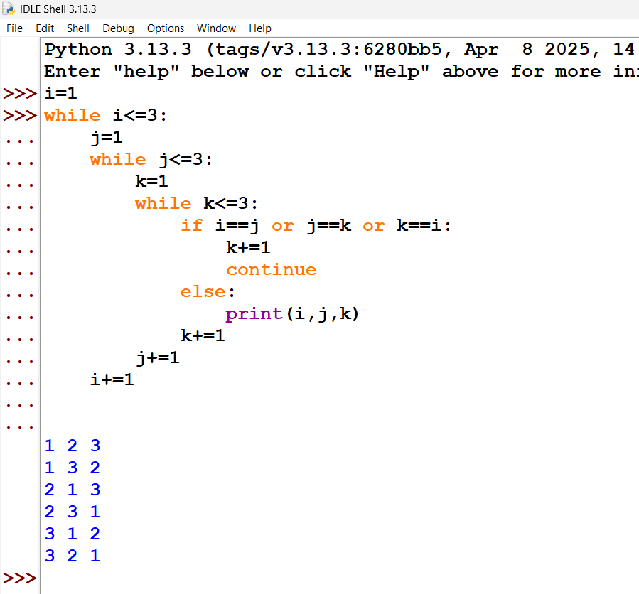

Q9. Write Python Program to understand Positional arguments and keyword arguments

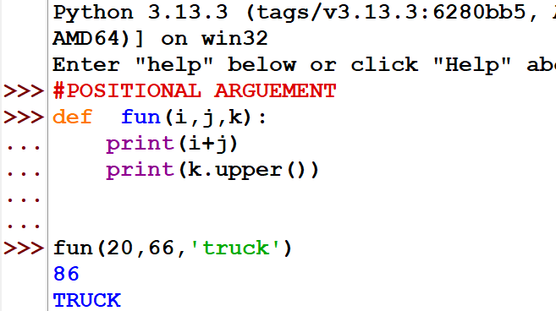

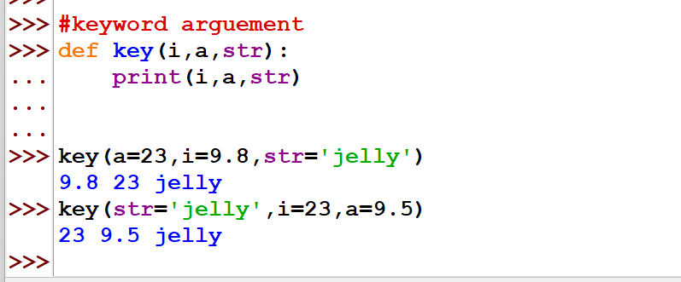

Q10. Write Python Program to understand Variable length positional argument & variable length keyword arguments.

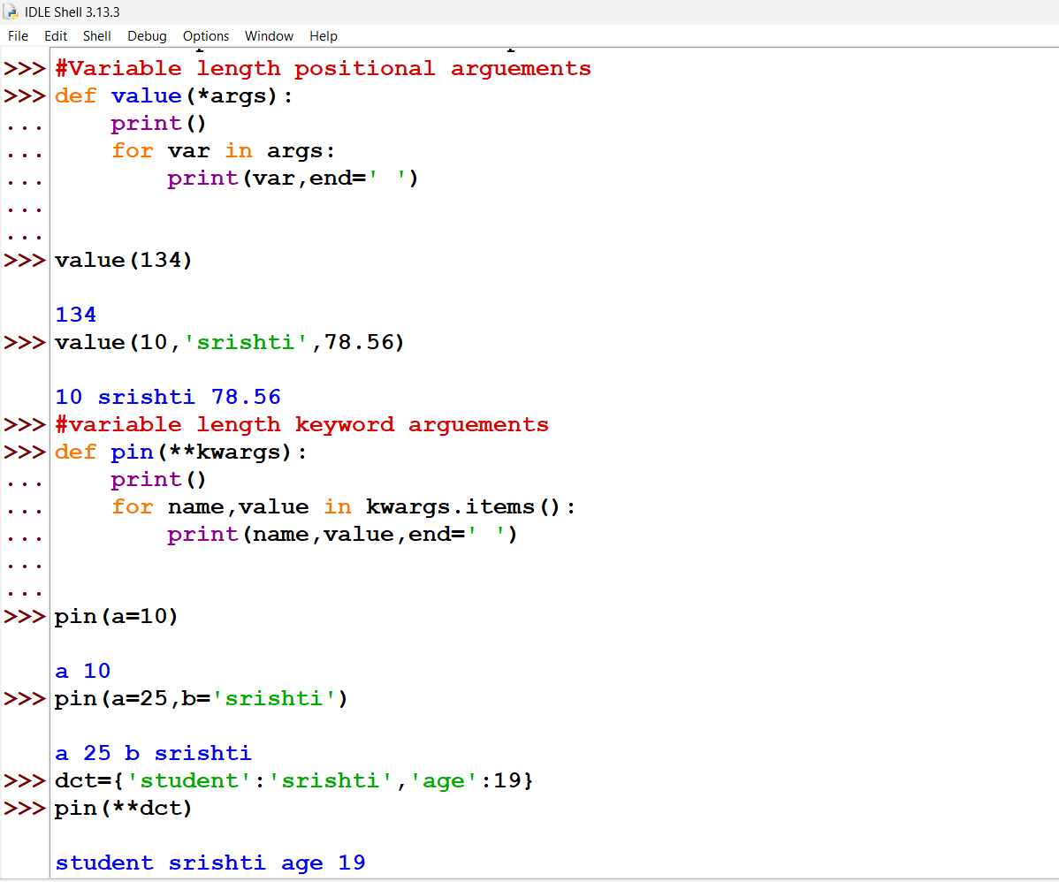

Q11. Write Python Program to understand to create & return a list containing tuples of the form (x, x^2, x^3) for all x between 1 and 20.

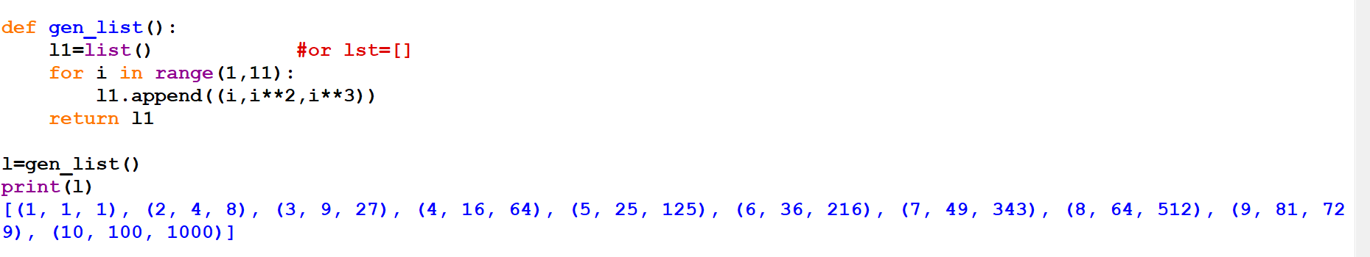

Q12. Write Python Program to understand to create user defined class for multiple inheritance.

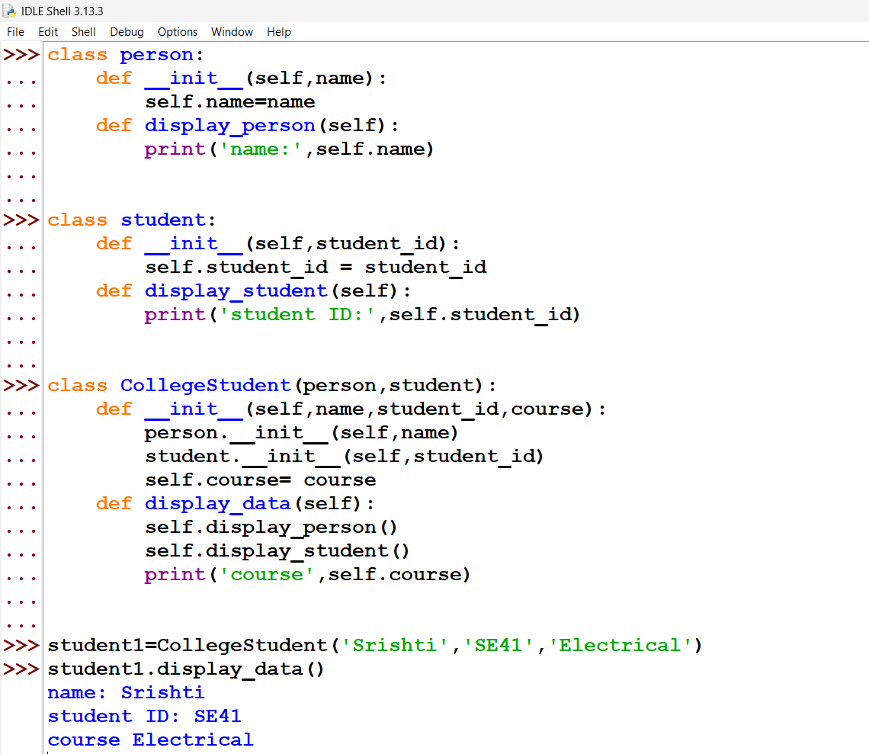

Q13. Write Python Program to understand to understand multiple inheritance using product, sales & Hardware item classes.

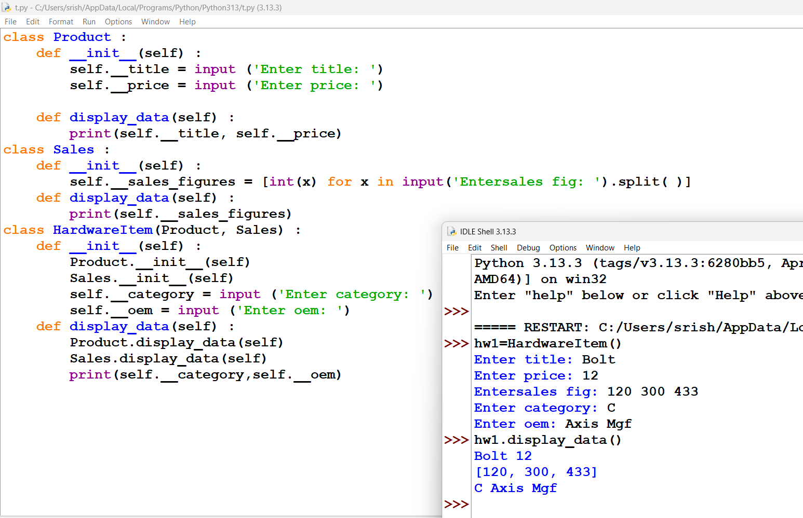

Q14. Write Python Program to understand Basics of numpy operations.

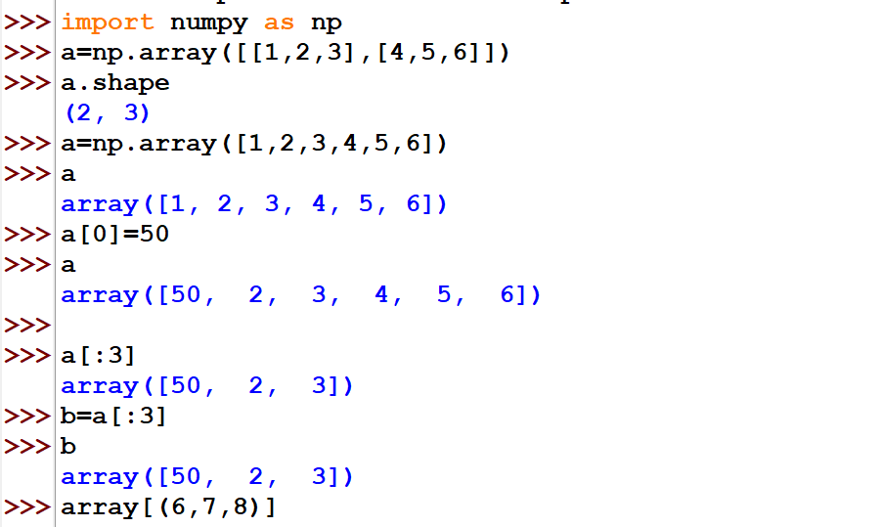

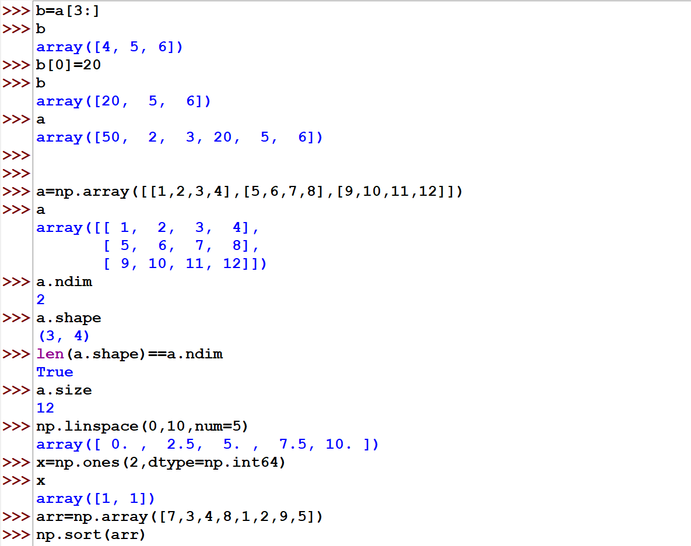

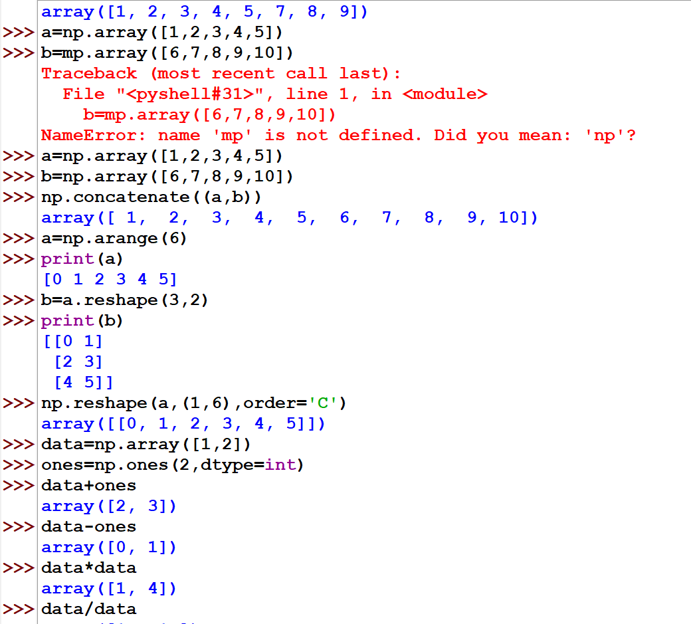

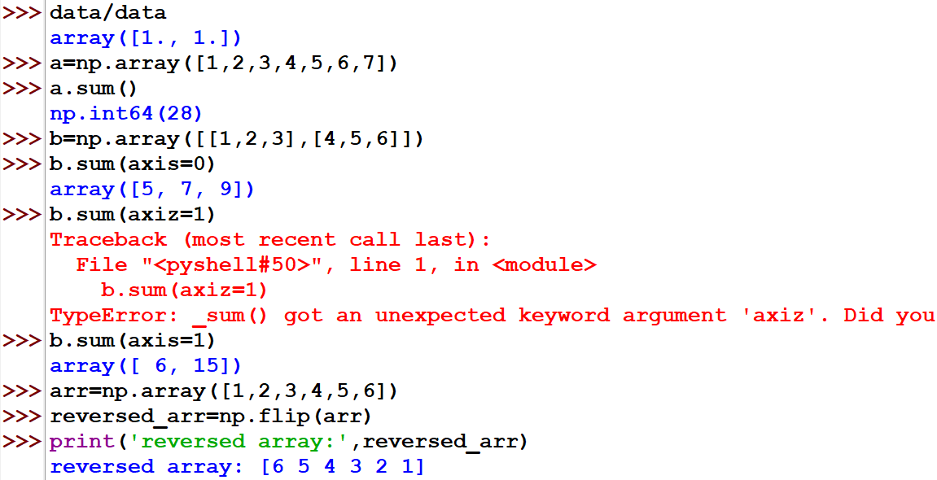

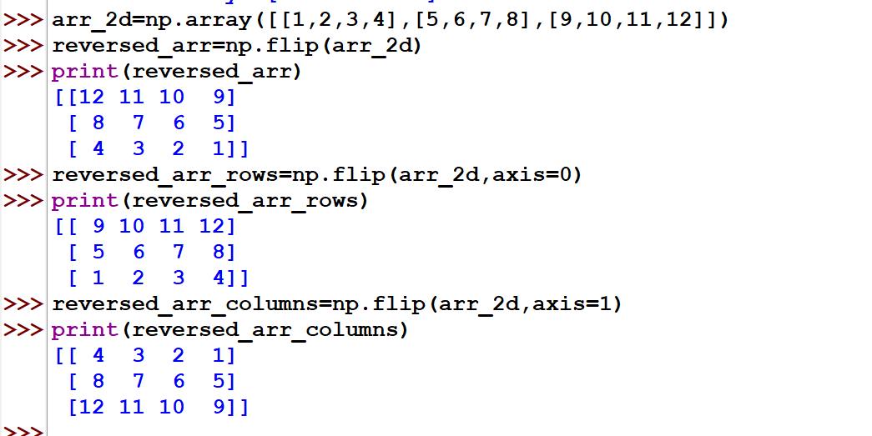

Q15. Write Python Program to understand 5 types of built in functions to be done on List.

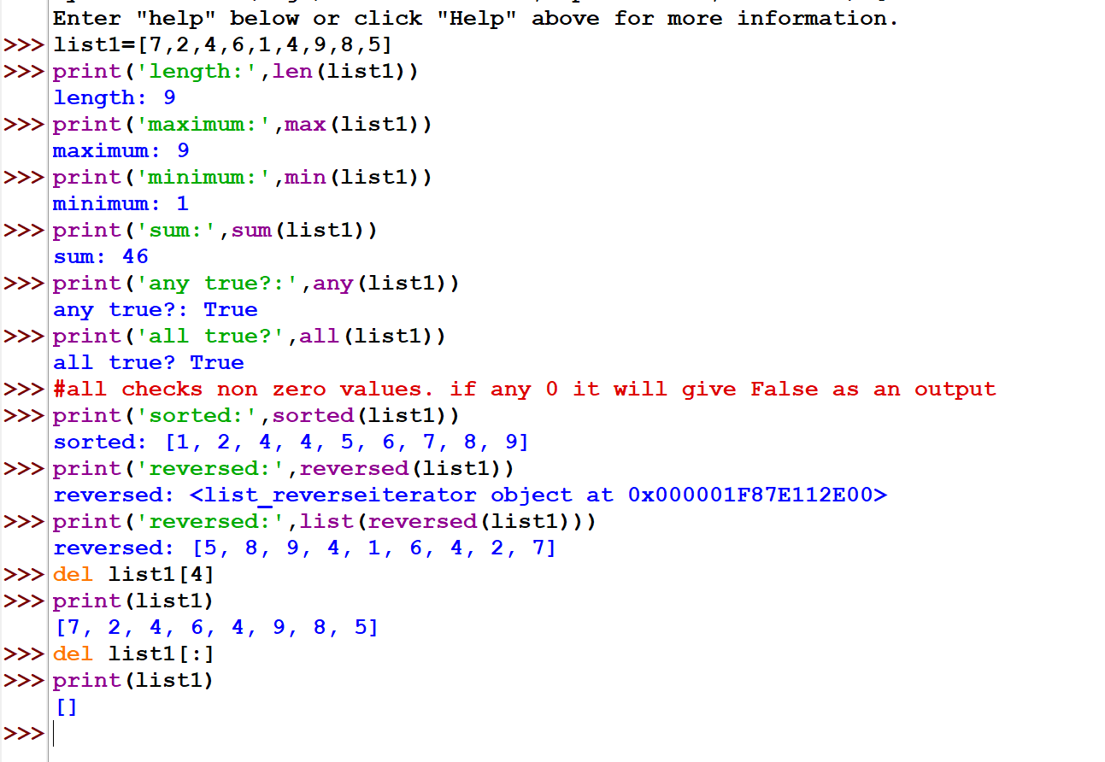

Q16. Write Python Program to understand Basics of Matplotlib operations.

Q17. Write Python Program to understand Basics of Scipy operations.

Q18. Write Python Program to understand Basics of GUI programming.

Q19. Write Python Program to understand Function in function.

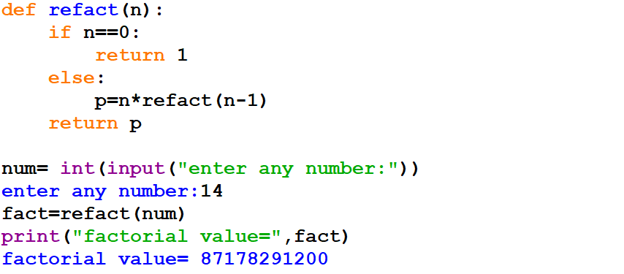

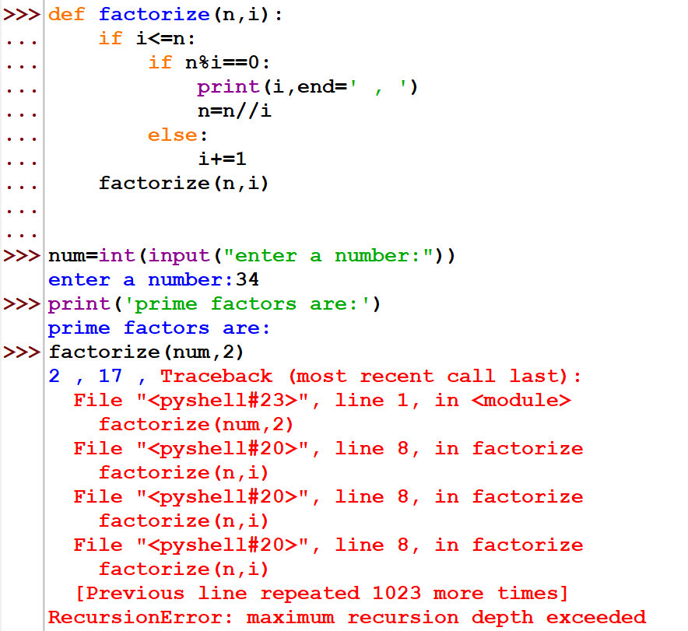

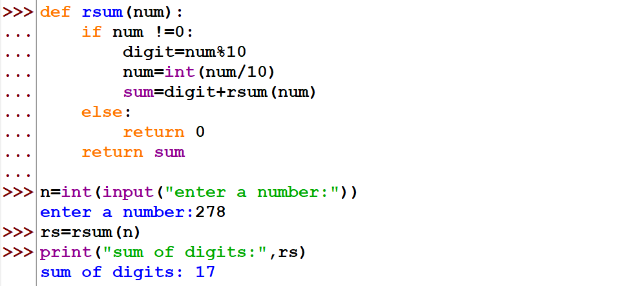

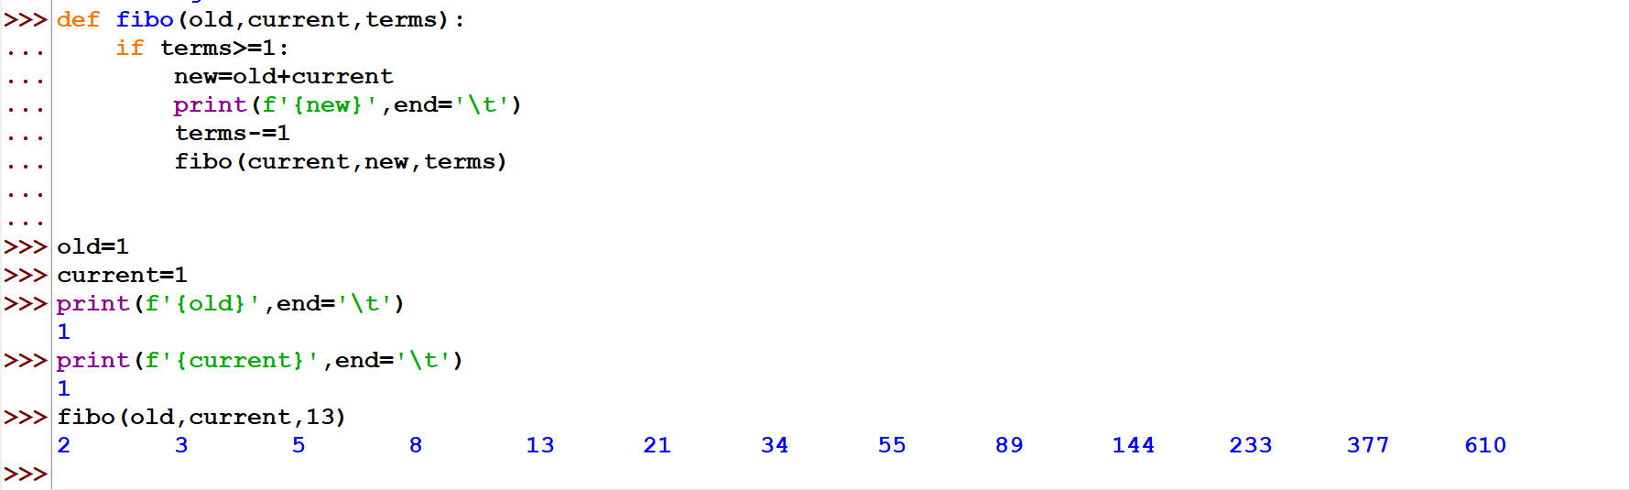

Q20. Write a Python Program to understand database operations using sqlite3.

Q21. Write a Python program for file input output operations.

#NOTE:- JOH QUESTIONS KE SOLUTION NAHI HAI WHO APNI PYTHON FILE SE DEKH LENA :)